Opening Cutscene [Event Pages]
What kind of a game where you get to school is a game without an opening cutscene?
Make an opening cutscene to get the player hooked on the plot straight from the get-go.
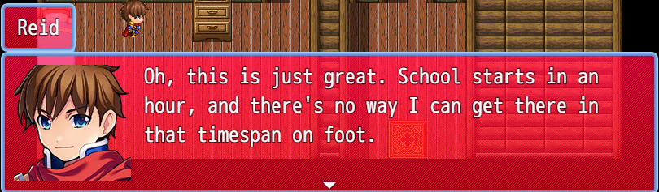
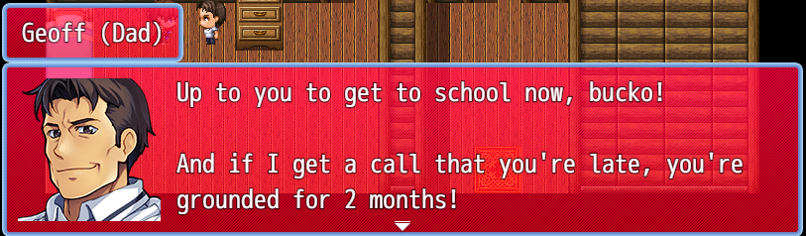
This scene can be whatever you want it to be that is related to the game’s main plot, whether it be the main character waking up and realizing how late they are, and this can also include them getting scolded by their mom or dad (or both, if you want to do that). Here are 2 shots from a cutscene that I made a while back.
To start, go into a map that you have already made. Let’s say it’s your house, assuming that’s where the game starts. This can be outside or inside, whatever you like. Or, it can be Reid in a dream-like state like I did with my cutscene. If you’d like, you can use the flowchart I came up with for the cutscene that I came up with after cutting it down.
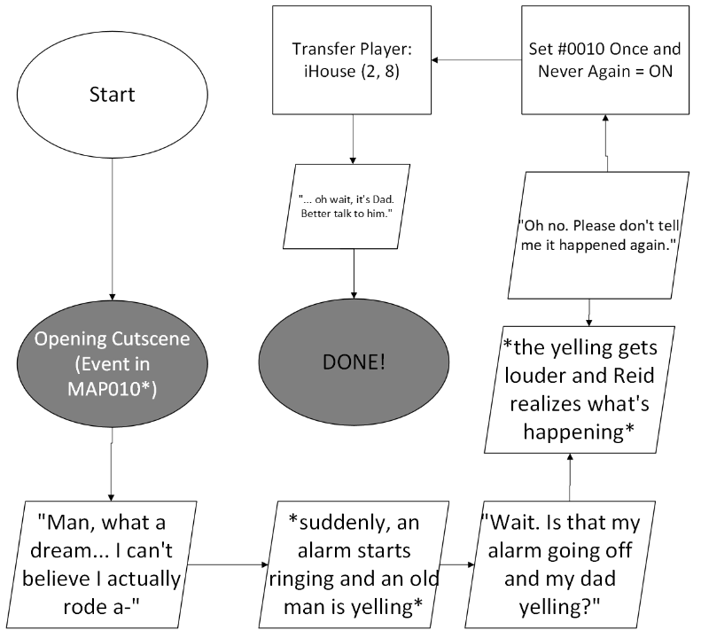
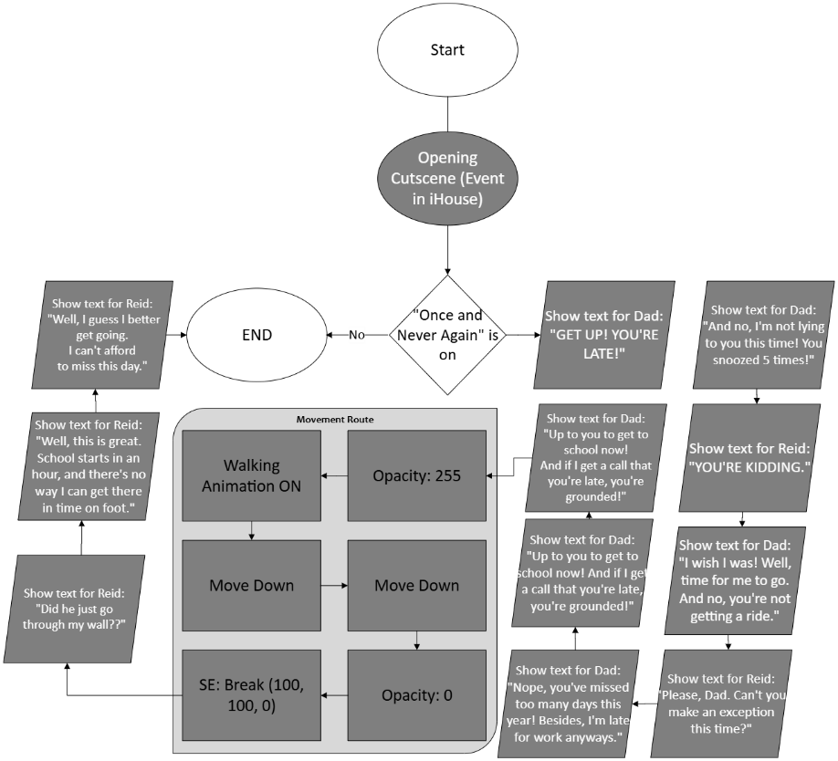
Part 1: Part 2:

You can just do part two if you want to start straight from the house. You don’t have to follow the text boxes word for word, you can add whatever you want in there. You can also add whatever effects that you like, such as the screen shaking, fading in or out, and sound effects (like I did when Dad walks through your wall.)

